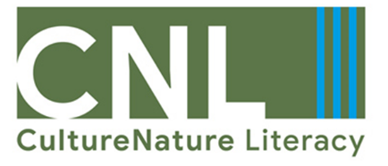
check list quality board: Approval Form

Date:
Author:

Chair:

Work Package:
□ WP1 CNL Manual Part 1
□ WP1 CNL Manual Part 2
□ WP2 CNL Platform
□ WP2 CNL Learning Scenarios
□ WP3 CNL MOOC
□ WP4 CNL Narratives

☒ Select one
Evaluation
Rating: (max. 10 Points each)

Specific objectives of this work package: …./10
Contribution to the general objectives of the project: …./10
Qualitative indicators (quality criteria) – level of achievement: …./10
Quantitative indicators – level of achievement: …./10
Defined processes were kept: …./10
Total: …./50

Revision is required if less than 45 points are reached.
☒ Select one
Revision required: Yes No
by (date):

Recommendations:



